Storage Account cost in Azure
19 August 2024
23:05

https://azure.microsoft.com/en-in/pricing/details/storage/blobs/

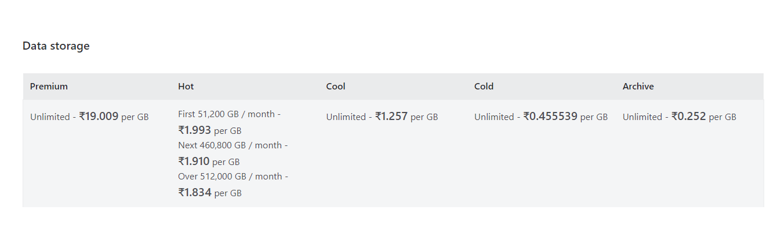
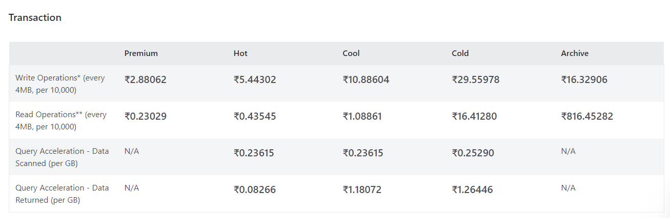

Azure synapse cost
20 August 2024
11:22

Serverless SQL Pool:-

Dedicated SQL pool:-

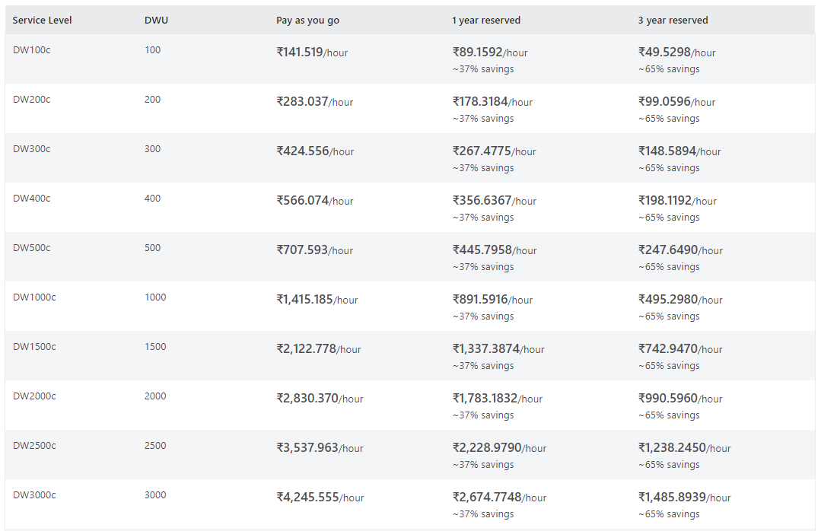
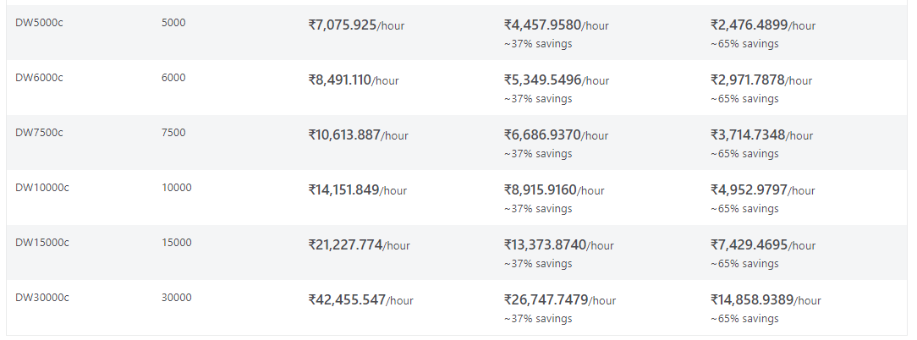

“DW100c” designation specifies a configuration of 100 Data Warehouse Units.

“c” in DW100c stands for "compute optimized". This means it is designed to balance computing power and cost-efficiently, efficiently handling data analysis tasks.

Apache Spark Pool:-

A Memory Optimized configuration uses more RAM to process large datasets faster by keeping the data in memory, improving performance for big data processing.

Key vault cost
21 August 2024
21:53

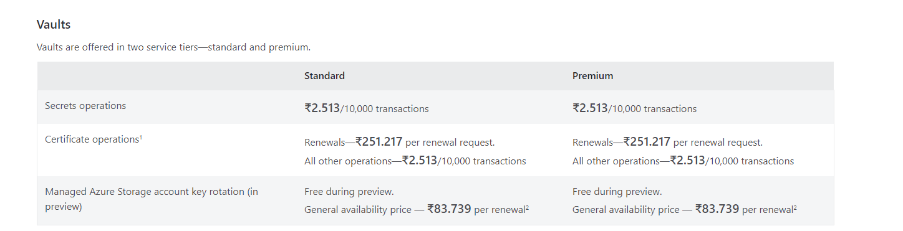

ADF cost
22 August 2024
11:59

https://azure.microsoft.com/en-in/pricing/details/data-factory/data-pipeline/

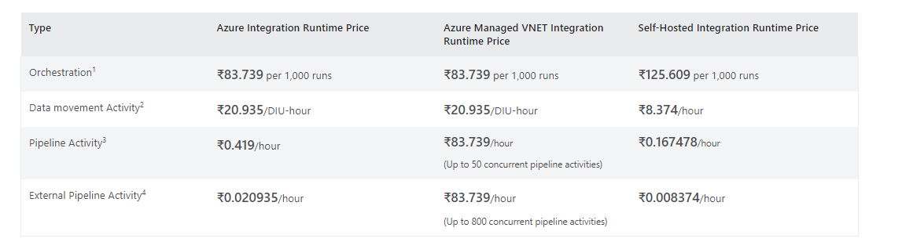

Overall cost by services
28 August 2024
12:31

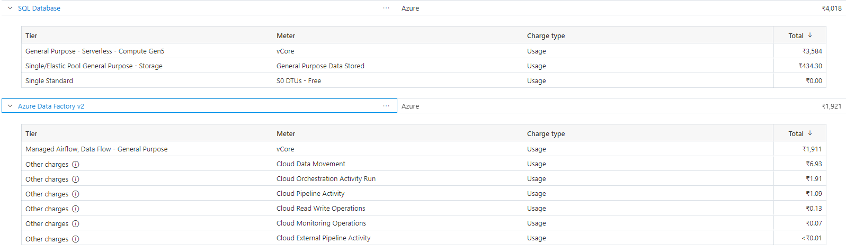

Azure Databricks Cost
29 August 2024
12:27

